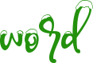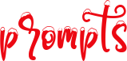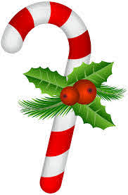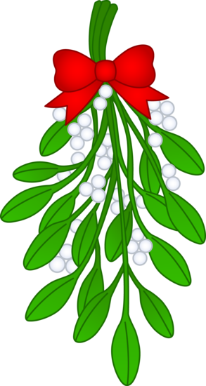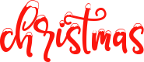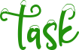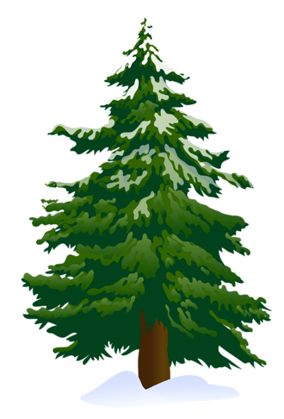

* Candles
* Holly
* Snow
* Jesus
* Mary
* Manger
* Tree
* Lights
* Decorations
* Baubles
* Winter
* Hats, scarfs, gloves
* Carrot
* Snowman
* Reindeer
* Santa
* Presents
* Ribbon
* Wrapping
* Turkey
* Dinner
* Red nose
* Rudolph
* Star
* Red, green, gold
* Holiday
* Warmth
* Carols
* Scrooge
* Grinch
* Milk and Cookies
* Fire
* Bethlehem
* Family, friends, loved ones
* Candy cane
* North pole

For this Christmas themed pack, you can get creative with the templates and colour, paint or collage them in a material/medium of your choice.

Or

Choose a few words from the word prompt list below to come up with your own design/drawing based on the words you have chosen.